PRACTICAL 9 – AUTOMATION TESTING (ORANGEHRM)
Project Name: OrangeHRM Testing
Module: Login, Dashboard, Admin, PIM, Leave, Time
Testing Type: Automation Testing
Webpage URL: https://opensource-demo.orangehrmlive.com/
● Scenario ID: SC_001
Scenario: Valid Login
Test Steps:
1. Open OrangeHRM login page
2. Enter valid username and password
3. Click Login
Test Input | Admin / admin123
Expected Result | Dashboard opens
Actual Result | Dashboard opened
Status | Pass
Screenshots:
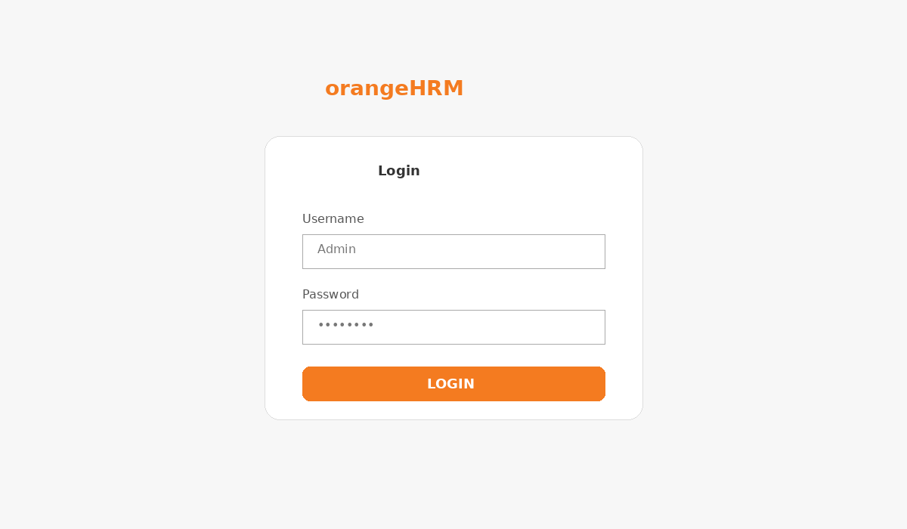
OrangeHRM reference screenshot – Valid Login
● Scenario ID: SC_002
Scenario: Invalid Login
Test Steps:
1. Open login page
2. Enter invalid credentials
3. Click Login
Test Input | Invalid / Invalid
Expected Result | Error message displayed
Actual Result | Error displayed
Status | Pass
Screenshots:

OrangeHRM reference screenshot – Invalid Login
● Scenario ID: SC_003
Scenario: Blank Login
Test Steps:
1. Open login page
2. Leave fields blank
3. Click Login
Test Input | Blank
Expected Result | Required field message displayed
Actual Result | Validation displayed
Status | Pass
Screenshots:

OrangeHRM reference screenshot – Blank Login
● Scenario ID: SC_004
Scenario: Dashboard Verification
Test Steps:
1. Login successfully
2. Observe dashboard widgets
Test Input | Valid credentials
Expected Result | Dashboard widgets are displayed
Actual Result | Widgets displayed
Status | Pass
Screenshots:
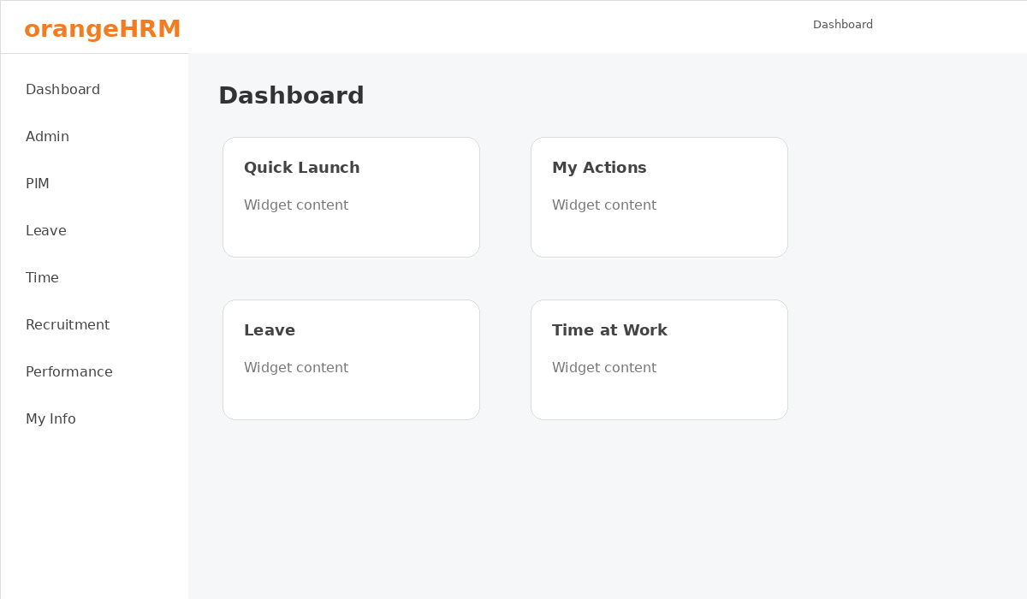
OrangeHRM reference screenshot – Dashboard Verification
● Scenario ID: SC_005
Scenario: PIM Module Access
Test Steps:
1. Login
2. Click PIM
Test Input | Valid login
Expected Result | PIM module opens
Actual Result | PIM opened
Status | Pass
Screenshots:
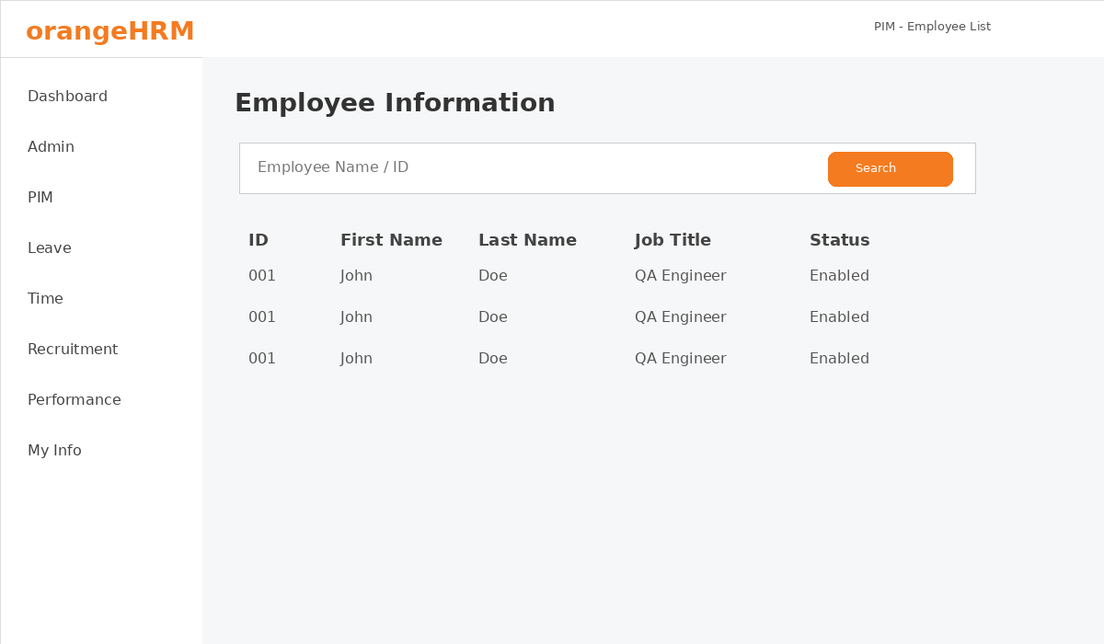
OrangeHRM reference screenshot – PIM Module Access
● Scenario ID: SC_006
Scenario: Employee List Display
Test Steps:
1. Open PIM
2. Open Employee List
Test Input | PIM
Expected Result | Employee list displayed
Actual Result | Employee list displayed
Status | Pass
Screenshots:

OrangeHRM reference screenshot – Employee List Display
● Scenario ID: SC_007
Scenario: Search Employee
Test Steps:
1. Open Employee List
2. Enter employee name
3. Click Search
Test Input | John
Expected Result | Matching employee displayed
Actual Result | Matching employee displayed
Status | Pass
Screenshots:

OrangeHRM reference screenshot – Search Employee
● Scenario ID: SC_008
Scenario: Reset Employee Search
Test Steps:
1. Enter search criteria
2. Click Reset
Test Input | John
Expected Result | Search fields reset
Actual Result | Fields reset
Status | Pass
Screenshots:

OrangeHRM reference screenshot – Reset Employee Search
● Scenario ID: SC_009
Scenario: Add Employee
Test Steps:
1. Open PIM
2. Click Add
3. Enter employee details
4. Click Save
Test Input | John Doe / EMP001
Expected Result | Employee is added
Actual Result | Employee added
Status | Pass
Screenshots:
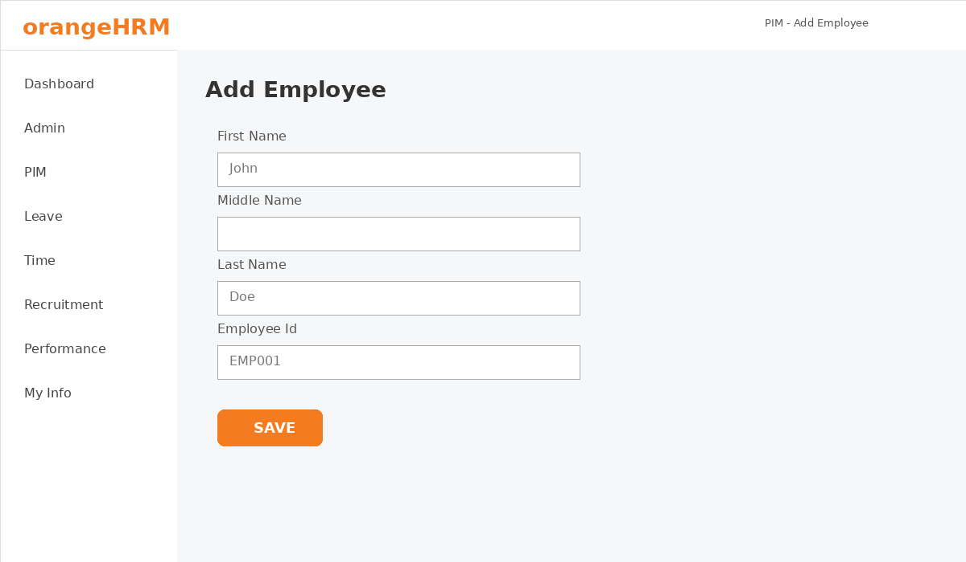
OrangeHRM reference screenshot – Add Employee
● Scenario ID: SC_010
Scenario: Mandatory Employee Fields
Test Steps:
1. Open Add Employee
2. Leave required fields blank
3. Click Save
Test Input | Blank
Expected Result | Validation messages displayed
Actual Result | Validation displayed
Status | Pass
Screenshots:

OrangeHRM reference screenshot – Mandatory Employee Fields
● Scenario ID: SC_011
Scenario: Employee ID Verification
Test Steps:
1. Open Add Employee
2. Verify Employee ID field
Test Input | EMP001
Expected Result | Employee ID field is available
Actual Result | Field available
Status | Pass
Screenshots:

OrangeHRM reference screenshot – Employee ID Verification
● Scenario ID: SC_012
Scenario: Edit Employee
Test Steps:
1. Search employee
2. Open employee record
3. Edit details
4. Save
Test Input | John Doe
Expected Result | Updated details saved
Actual Result | Details saved
Status | Pass
Screenshots:

OrangeHRM reference screenshot – Edit Employee
● Scenario ID: SC_013
Scenario: Delete Employee
Test Steps:
1. Select employee
2. Click Delete
3. Confirm deletion
Test Input | Employee record
Expected Result | Employee is removed
Actual Result | Employee removed
Status | Pass
Screenshots:

OrangeHRM reference screenshot – Delete Employee
● Scenario ID: SC_014
Scenario: Leave Module Access
Test Steps:
1. Login
2. Click Leave
Test Input | Valid login
Expected Result | Leave module opens
Actual Result | Leave opened
Status | Pass
Screenshots:
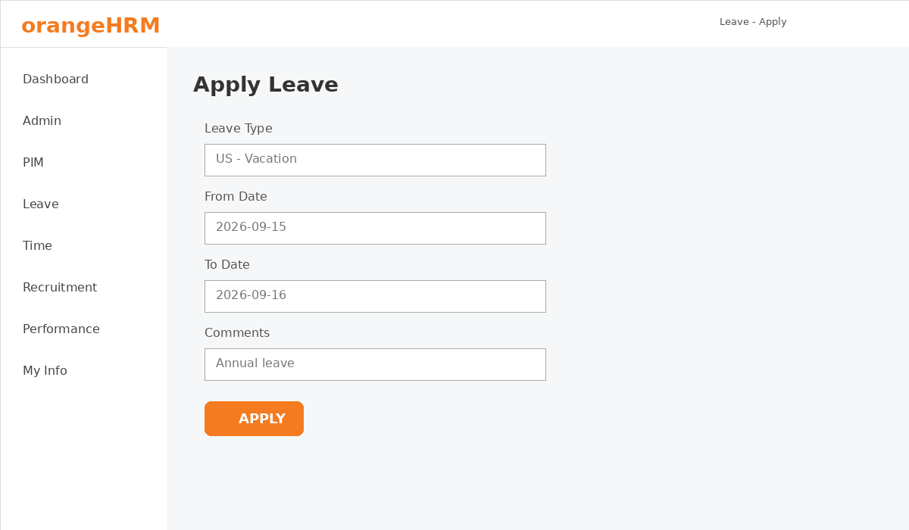
OrangeHRM reference screenshot – Leave Module Access
● Scenario ID: SC_015
Scenario: Apply Leave
Test Steps:
1. Open Leave
2. Select leave type
3. Enter dates
4. Click Apply
Test Input | Vacation / 15-16 Sep
Expected Result | Leave request submitted
Actual Result | Request submitted
Status | Pass
Screenshots:

OrangeHRM reference screenshot – Apply Leave
● Scenario ID: SC_016
Scenario: Leave Validation
Test Steps:
1. Open Apply Leave
2. Leave required fields blank
3. Click Apply
Test Input | Blank
Expected Result | Validation displayed
Actual Result | Validation displayed
Status | Pass
Screenshots:

OrangeHRM reference screenshot – Leave Validation
● Scenario ID: SC_017
Scenario: Leave Date Verification
Test Steps:
1. Select From and To dates
2. Verify dates
Test Input | 15-16 Sep
Expected Result | Dates accepted
Actual Result | Dates accepted
Status | Pass
Screenshots:

OrangeHRM reference screenshot – Leave Date Verification
● Scenario ID: SC_018
Scenario: Time Module Access
Test Steps:
1. Login
2. Click Time
Test Input | Valid login
Expected Result | Time module opens
Actual Result | Time opened
Status | Pass
Screenshots:

OrangeHRM reference screenshot – Time Module Access
● Scenario ID: SC_019
Scenario: Admin Module Access
Test Steps:
1. Login
2. Click Admin
Test Input | Admin credentials
Expected Result | Admin module opens
Actual Result | Admin opened
Status | Pass
Screenshots:

OrangeHRM reference screenshot – Admin Module Access
● Scenario ID: SC_020
Scenario: Logout
Test Steps:
1. Login
2. Open user menu
3. Click Logout
Test Input | Valid login
Expected Result | Login page displayed
Actual Result | Login page displayed
Status | Pass
Screenshots:
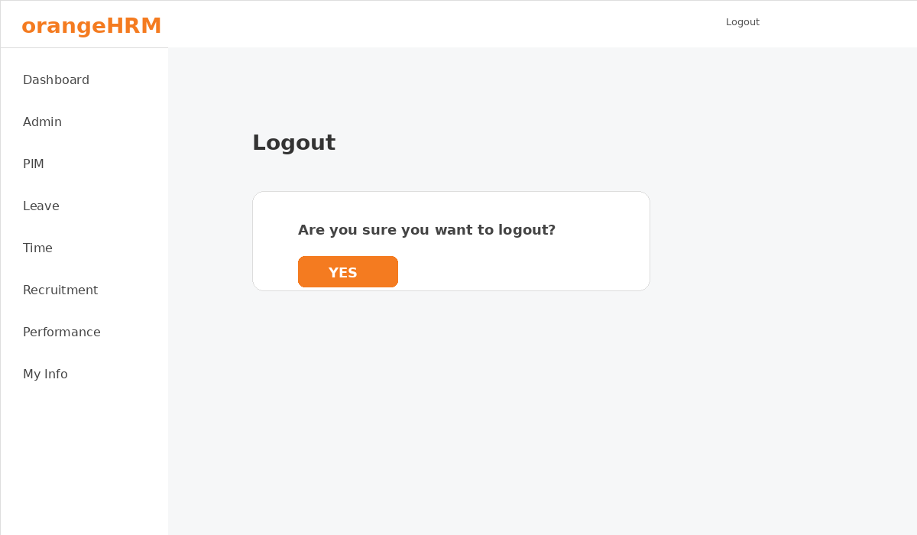
OrangeHRM reference screenshot – Logout

Summary of Test Results
Total Scenarios: 20
Passed: 20
Failed: 0
Automation Tool: Selenium WebDriver with Python

Conclusion and Recommendations

Conclusion
Automation testing was performed on the OrangeHRM web application for critical and repetitive HR functionalities. The selected scenarios were verified successfully.

Recommendations
Automate repetitive login, employee-management and leave-management scenarios with Selenium and execute the suite after application changes.

Bug Report
No defects were observed in the scenarios recorded for this practical.

